 Catchment Update
2012
In General: As the weather returned to normal the focus of our catchment group turned to the up coming election in October. A number of public forums were held to discuss the blue/green algae blooms and other problems experienced in Lake Tuggeranong over summer and autumn. More on this below.
The slower flows in the Murrumbidgee River gave the mud time to settle most sites recorded crystal clear waters all winter.
We also welcome Kyle Maley who usurps Josh and the boys with the honor of being our youngest volunteer. Kyle is in Year 7 this year and has taken ownership of Stranger Pond in Bonython.

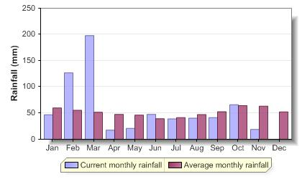
Rainfall statistics courtesy of ActewAGL website

PLEASE SEE NOTE ON PHOSPHATE READINGS BELOW.
Water Temp: The coldest water this season 1.1°C in Paddy’s River at the Tidbinbilla Rd bridge site. I hope Miranda was wearing gloves!
pH: 9.6 at Casuarina Sands in August. All other sites were well within the normal range this season.
E.C: No readings of concern this season.
Turbidity: While the Murrumbidgee was pretty clear this season, Paddy’s River and the lower Cotter had pretty turbid conditions.
Dissolved Oxygen: Good, healthy readings.

Phosphorus: We have been incorrectly recording our results for this test as ‘phosphates’. The wheel in the Visocolor kits actually gives the total dissolved phosphorus in the sample. This will have an effect on how I respond to the results submitted but no effect on your monitoring.

Nitrates and Nitrites: No readings of concern this period.
Algae: Algae populations popped up in greater number than the last season, possibly due to the lower flows. High flows flushed away a lot of the algae build up at many sites in autumn and winter saw the re-emergence of diatom colonies at many sites as the single celled plants got to work absorbing silica to make new homes.

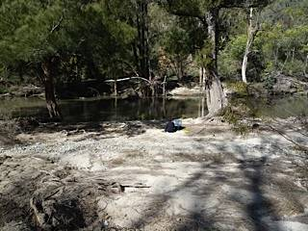
Lower Murrumbidgee:
(Includes Uriarra Crossing, Casuarina Sands and the Cotter Camp ground sites.)
Some interesting developments below the Cotter dam site. Casuarina Sands had a spike in high pH possibly from concrete contamination from the dam construction, which is in its final stages. The Cotter Campground experienced some clearing activity presumably in readiness for the reopening of the camp site to the public. High turbidity in the lower Cotter River reflected the construction activity upstream.

Clearing work near Cotter campground. Photo Fleur Horan
Upper Murrumbidgee:
(All Murrumbidgee sites up stream of the Cotter junction. Includes lower Gudgenby River site and all creeks and dams east of the Murrumbidgee not flowing into Lake Tuggeranong)
The Murrumbidgee enjoyed a reprieve from high flows to once again become crystal clear. This really does show the importance of high flow events for the health of this river. The awful build up of suspended clay seen in previous years as a result extended drought reminds us of how vulnerable our river systems are to the negative effects of prolonged deprivation of water.
The Upper Murrumbidgee Actions for Clean Water (ACWA) plan was launched in August and heralds a big milestone in cross boarder partnerships as well as strong links between government, corporate and community bodies. Our Murrumbidgee Waterwatch data has been a key ingredient in this success.
“The ceremony was conducted by the chair of the Upper Murrumbidgee Catchment Coordinating Committee (UMCCC) Peter Duffy, Acting Chair of the Murrumbidgee CMA Sulari Goonetilleke, ACTEW’s Managing Director Mark Sullivan and ACT Environment & Sustainable Development Minister Simon Corbell.” (from CMA media release)

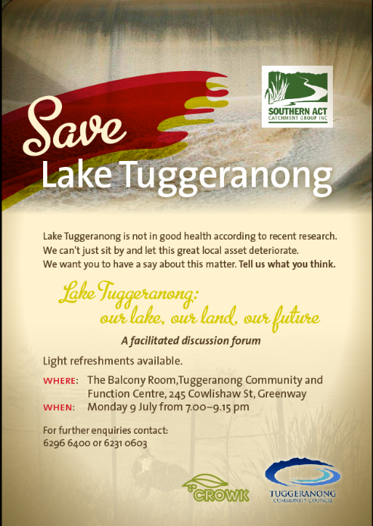
Tuggeranong:
(Tuggeranong Creek and all storm waterways flowing into Lake Tuggeranong.)

Our little lake made it into the local news more often than ever this season. There was an article in every edition of the Chronicle as well as appearances in The Canberra Times, Radio 2CC and ABC Radio and TV.
She nearly took to wearing dark sunglasses to avoid the paparazzi.
The blue green algal blooms earlier in the year leading to prolonged lake closures combined with similar events in Lake Burley-Griffin drove an unprecedented level of public interest. The SACTCG joined the Tuggeranong Community Council in hosting public forums on what should be done. The great outcomes of these will be revealed in the spring update! (which may arrive by Christmas.)

Cotter:
(Intermittent WW data collected. This catchment is also extensively monitored by ActewAGL.)
The final stage of the dam construction got well underway in winter after the clean up following the March floods. Cracks that appeared in the new concrete and the budget blowout kept the dam in the pre election spot light.
The Yurung Dhaura team reported that it was all quite on the western front.

Paddy’s:
(Includes Paddy’s River, Gibraltar Creek in Corin Forest and all sites in the Tidbinbilla Nature Reserve)
There were unusually high turbidity readings in the Paddy River throughout this season. Fleur and Maree noted some clearing up around Murray’s Corner and the sites up stream also had high turbidity readings. I wonder if in-stream re-fencing work had been taking place on Paddy’s River properties to repair damage by the floods.
Miranda made the awful discovery of a dead dog dumped along with its bedding at our most notorious site in this catchment, and Maree and Fleur put out a fire left burning by a group of morons not far down stream. This reminds me that are often the most regular visitors to many of our sites around the ACT, so it is extremely likely that we will be the ones to uncover the legacies of some of the worst human behaviours.
Please remember your safety and wellbeing (physical and mental) are my main concern. You are the SACTCG’s most precious resource.
When monitoring, please:
- Take a friend. Nothing is safer than another pair of hands.
- Check phone coverage. Come and get the EPIRB off me if necessary-it’s small and it’s free.
- Take your First Aid kit. If you don’t have, one let me know.
- Take your camera. This is how vandals were busted at Kambah Pool. Rego’ numbers on cars are incredibly handy.
- Don’t approach yobs. Police assistance is 131 444 for general idiot behaviour.

Gudgenby:
(Includes all creeks and streams flowing into the Gudgenby River. Most sites are in the Namadgi National Park).
Cool, quiet and crystal clear. Martin reported happy streams in the Namadgi NP this season.
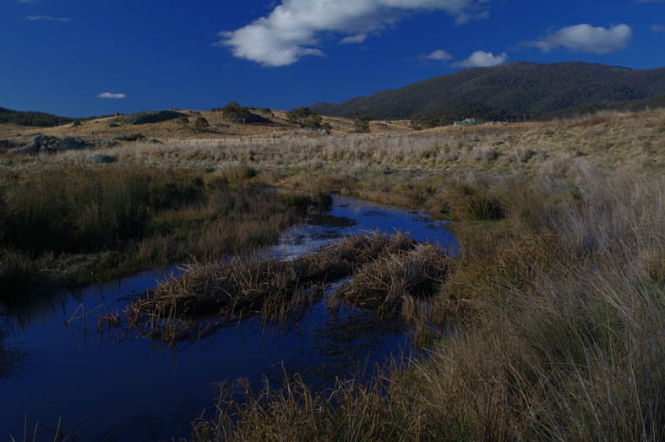
Bogong Creek looking north last June. Photo: Martin Chalk

Naas:
(Includes all creeks and streams flowing into the Naas River).

Ian reported similar conditions to the Gudgenby catchment. The Naas river was as clear and clean as he has seen it since he began monitoring. A further testament to the power of good rain and some good flushing flows.
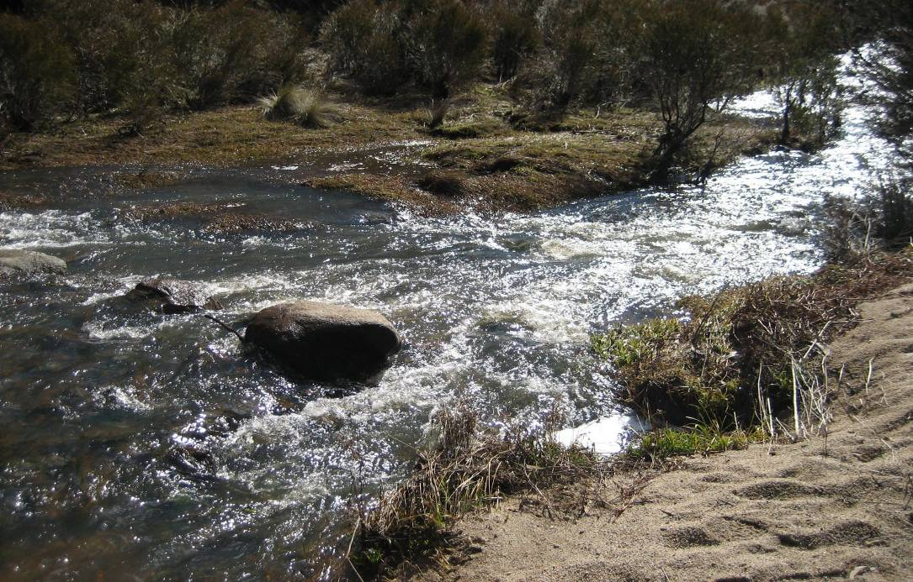
The Naas River high up at the Namadgi Park boundary in July. Photo Ian Long.

A huge thank you to all those groups and individuals involved in collecting data for this update. Waterwatch volunteers provide vital and immediate information on the state of our waterways which is being increasingly used by government and corporations locally and nationally. For more information contact the SACTCG Waterwatch Coordinator on 62966400 or Waterwatch@sactcg.org.au

Martin Lind.



