SACTCG Waterwatch bulletin september 2021
Hi,
Lockdown, and therefore the pregnant pause on Waterwatching, has been extended until mid October. The ACT government hold the ultimate responsibility for Waterwatch volunteers. So, as you can imagine, reducing risks to your health and wellbeing is a priority. Be rest assured your importance has not been entirely forgotten. Negotiations are happening behind the scenes to get you back on the job asap. That said, I hope that you are maintaining your brain, as well your body. To help a bit with the former I have collected some links and newsletters. Lots here this month for your reading/viewing interest. Definitely take the time to view the wonderful videos and webinars under the Waterwatch banner below.
Take care and stay well,
Martin Lind
Waterwatch Coordinator.

Stephen Dellar; Carers of Point Hut Pond Waterwatch since 2014
“When I retired from full time work in 2009 I wanted to continue to be involved in productive activity and to try to give something back to the community. I had spent many years working in a very demanding job and it had meant that a consequence for me was that while I drove through my suburb pretty much every day on my way to work and on my way home again I had no contact with my community and knew virtually no one who lived in my street or in my neighbourhood.

So I looked around for something to do and found a couple of opportunities, including taking an interest in the environment. Like most people I want our environment to be protected, and to be there when my grandchildren become adults.

One opportunity that looked promising was a group that was being formed to take an interest in our local Point Hut Pond. So I got involved and helped to create that group and we spent our time lobbying Government for improvements and undertaking voluntary work to enhance the Pond and surrounds. One of the things I did as a part of that was to begin to undertake Waterwatching which was integral to the care for this particular waterway. I am not quite sure exactly when I started the testing program, but I know it was at least 8 years ago and probably longer than that.

So I think I must have undertaken well over 100 tests for my own site at the southern edge of the Pond, and I often helped out with the testing of other sites.
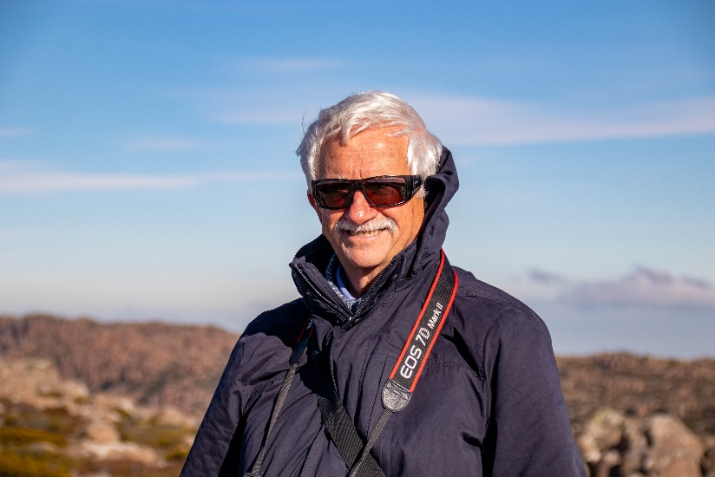
The rewarding part of the work is to know you are doing something which helps keep our waterways maintained, and in the case of Point Hut our water supply as well.

It was always interesting to observe the changing environment and to see the birds and other wildlife and the people who enjoyed the pool and its surrounds. As well I have seen many improvements around the lake in the years I have been volunteering, and it’s a pleasure to know I have made a small contribution in that regard.

Working with Martin has always been a pleasure. He is clearly committed to the environment and has always been cheerful and helpful throughout the years that I have been involved in Waterwatch.”

Stephen Dellar
(Thanks Stephen. The money’s in the post.)

Southern ACT Catchment Group news and events;
Head to SACTCG Calendar/News for the latest on the SACTCG website.

Upper Murrumbidgee Waterwatch news and events;

- From Woo O’Reilly’s (UMWW Regional Facilitator) desk; “Just to cheer you up. A neat little video from the BBC highlighting that around 40 species of Australian frog are in a spot of bother. I spent a week searching for the Kroombit Tinker frogs in central Qld many years back. The footage of the steep country surrounded by palms is almost certainly there (enormous leeches..). The footage of the little brown frog making a sound like your tapping a glass is said frog. They sit in crevices in big boulders, bouncing their call off the rocks and are almost impossible to locate.”
- Upper Murrumbidgee Recovery Reach Native Fish Showcase Webinar Series
- Native Fish Showcase Webinar The first from the Series last Friday. The recording is now available on the Finterest website here, and you can also watch it by clicking below.

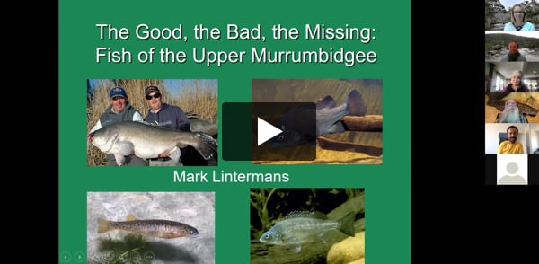

“If you enjoyed Mark's session, we recommend you check out these additional web pages and resources:”
Cheers,
Siwan and Antia 😊
Fish and Flows Forum
Rivers of Carbon – Upper Murrumbidgee River Rehabilitation Project
Podcast Episode - Saving Stocky, guest: Mark Lintermans

- From Anke Maria Hoefer’s (ACT FrogWatch Cordinator) desk;
The Bettong Bungalo: Frog Watch- now screening.

- From Deb Kellock’s (Coordinator, Friends of Jerrabomberra Wetlands) desk;
The Bettong Bungalow: Water Quality with Waterwatch – now screening

ACT Government Waterway updates;
Waterway closures. | Recreational Water Quality | Bacteria alerts
For water and sewerage faults and emergencies phone 02 6248 3111 (option 1)
Icon Water Eflow releases;
Below is a summary of water releases from Icon Water dams in the Southern ACT, courtesy of Sarah McLaren, Acting Team Leader Network Operations, Icon Water. This data is operational information and subject to change.

Bendora Currently overflowing. Flow below Bendora Dam approximately 430 ML/d. Release currently at licence requirements:
15 September 212.5 – 220.3 MLD 1.33 – 1.34 m 22 September 108.0 – 112.3 MLD 1.15 – 1.16 m
Licence requirements: 15 September 216 MLD 22 September 108 MLD
Corin Currently overflowing. Flow below Corin Dam approximately 350 ML/d. Release currently at licence requirements:
16 September 115 – 125 MLD 0.51 – 0.52 m 23 September 68.7 – 73.8 MLD 0.44 – 0.45 m
Licence requirements: 16 September 115 MLD 23 September 69.0 MLD
Cotter Currently overflowing. Current flow approximately 610 ML/d below dam. Current release is approximately 15 ML/d from the dam. Licence release requirements: Base release flow of >15 ML/d, with bi-monthly riffle release of >100 ML/d for >24 hours. OR Flow requirements as described in M2C section of the Water Abstraction EMP.

Other newsletters and links;
The views expressed in some media releases and opinion pieces are not necessarily the same as SACTCG or UMWW. But they make interesting reading and all sites linked to here are bonafide.

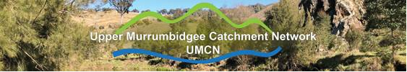
Elizabeth Goodfellow's talk on Climate-ready revegetation is a must see! You can find it on the UMCN website news page.
Kind regards,
Claire Sives
Executive Officer | UMCN

Murray Darling Basin Authority
- Hume Dam water releases increase to create airspace and reduce future flood impacts The following can be attributed to Murray-Darling Basin Authority (MDBA) acting Chief Executive Andrew Reynolds: The Murray-Darling Basin Authority has increased daily releases from Hume Dam to 31GL to manage airspace. Read more

CSIRO ECOS enewletter
Snapshot Newsletter
Canberra Environment Centre
Newsletter: Online events and workshops
Newsletter: Preparing for Spring
Murrumbidgee Landcare Newsletter
Feral Heral Newsletter
